College Students’ Associations
Realising Our Potential

College Students' Associations Showcase: 2013/14

There wasn’t room to fit all the amazing things students’ associations have been up to over the past year into the video. So in this pack you can find out more about what other students’ associations have been doing over the past year, their achievements, and their structures!
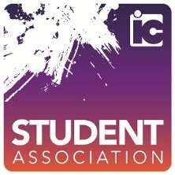
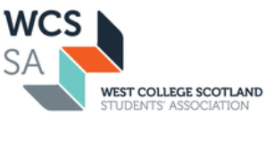
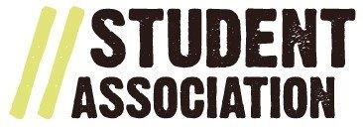
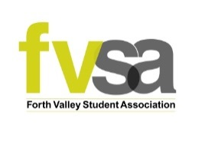
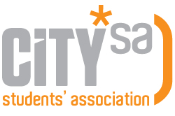
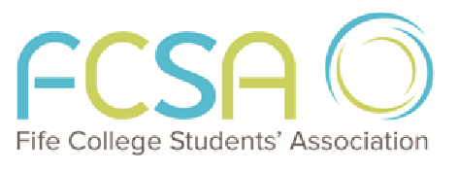
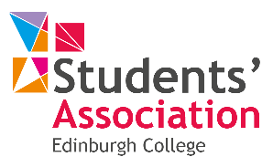
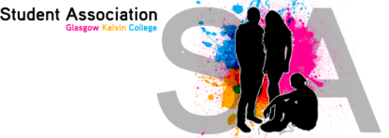
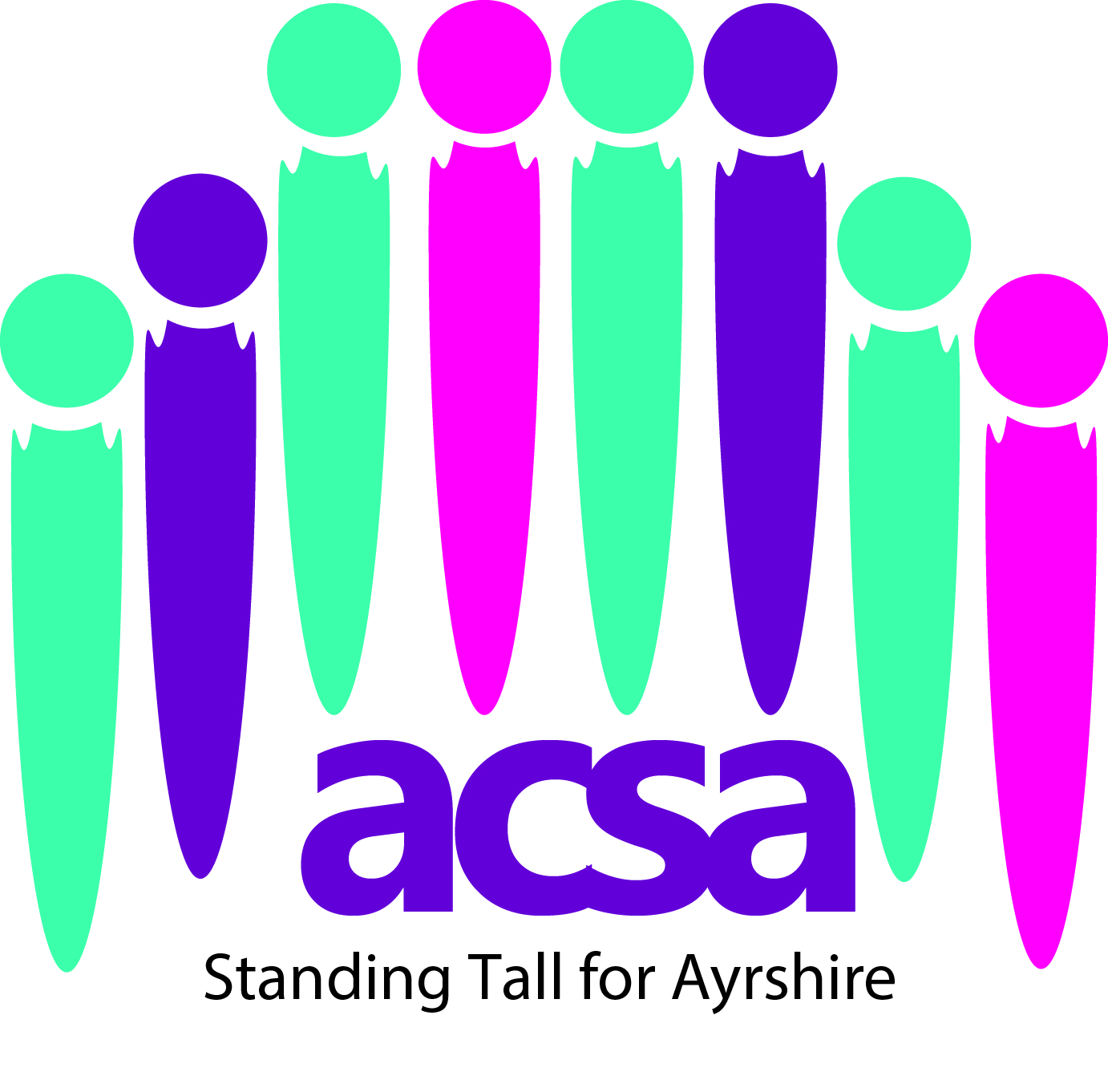

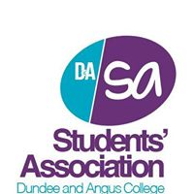

Thank you very much to all students’ associations who contributed to this pack! The contents will be going up on the sparqs website after the conference, for everyone to access. If you were not able to send us anything in time for the conference, please get in touch and we will include your showcase on the website.
We are always on the look out for case studies to share. Some of the best ideas and learning you can get come from hearing about what other college students’ associations are up to.
So if there is something you’re association does particularly well, or a challenging experience you have faced which you think others would learn from, please get in touch!
Kate.byford@nus-scotland.org.uk
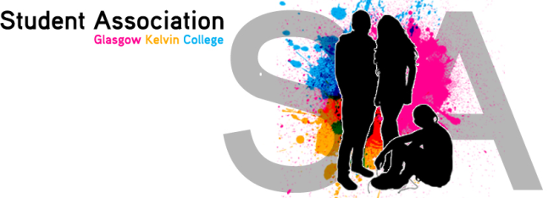

Glasgow Kelvin College Students’ Association

From November 1st 2013, John Wheatley College, North Glasgow College and Stow College merged to form Glasgow Kelvin College. A lot of changes have taken place regarding the Students’ Association in this time. Before merger we had three very different associations in the three legacy colleges. When we merged it created one big association with nine part time officers. The new association logo, above, was created in partnership with the colleges’ marketing department. The transition from three associations to one has been managed seamlessly, with support from staff, management, and board members.

During this time the association officers participated in training with NUS, sparqs and also within the college. This helped develop skills which enabled them to communicate better, grow in confidence and teach them how to approach management in order to make change within the college. This has impacted greatly on students’ lives, because they have been able negotiate with management to give students extra units they needed to progress onto further/higher education or work.

Andrew Aitken, president of the association, is a full member of Glasgow Kelvin Colleges’ Board of Management, where he has contributed greatly, and effectively represented students’ views in a confident and professional manner. It is planned that student officers will also be members of other boards and committees when they are established in the college.

Thanks have to go out to Mike Williamson, from Partnerships for Change, for all the support and time he has invested in the association. Eire Hawthorn, Vice President Learning and Teaching said, “Mike has been very supportive and has really helped me develop in confidence. He has also helped me gain skills and knowledge in order to help me effectively carry out my role”.

Through effective engagement with students, the turnout for class rep meetings have been greater than in previous years, with up to 40 students attending at our larger campuses. This has meant that when the college had its Annual Engagement Visit and other visits from the Scottish Funding Council, a variety of students from all areas of the curriculum have been able to give their views about all areas of the college.

This year Glasgow Kelvin College Students’ Association (GKCSA), has three full time sabbatical officers, in order to represent and meaningfully engage with students. The block grant has also significantly increased from around £4000 between the three legacy colleges, to £15,000 for this academic year.

This year GKCSA are looking to improve interaction with students. They also aim to improve the quality of learning and teaching by working closely with the class reps and providing them with sparqs and TUC training, to ensure they are effective within their roles. GKCSA will be encouraging students to get involved in shaping their own learning experience. So far this year, the association have carried out extensive planning to establish more clubs and societies in order to maximise student involvement. Andrew Aitken, President, said “We realise that there are still three cultures within Glasgow Kelvin, and we hope to create one, by organising activities, events and campaigns, and bringing students together to interact”.

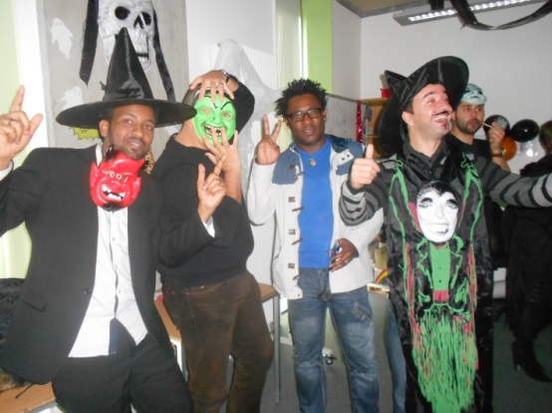
The first student event of Glasgow Kelvin College organised by the students’ association – a Halloween party attended by students of all five campuses. Money raised from the event was donated to charity.

Borders College Students’ Association

Since being given the opportunity to deliver tailored Class Rep training sessions, we now offer sessions specifically for our Access students, Rural Industries students and a further five sessions to suit timetables. From training around 25 Class Reps per year, the figures were 64 for 2012 and 57 for 2013. Several Class Reps have chosen to continue in the role for a second or third term in office.
Our Faculty Councils (chaired by a returning student, with members being the Class Reps from that Faculty and attended by the Head of Faculty, Programme Leaders, Vice Principal and Student Liaison Officer) have now become an established format for the student voice on teaching and learning issues with the Chair taking wider issues to the Student representative Council.

Edinburgh College Students’ Association

http://www.nusawards.org.uk/about/2014-shortlist/edinburgh-college-students-association/
Edinburgh College collected FE Students’ Union of the Year at the ceremony in Bolton
FE Students’ Union of the Year
“‘The ECSA vision is ‘to champion a life-changing educational experience at Edinburgh College’. ECSA’s key strategic aim is: Partnership and Representation.
ECSA has had a significant impact on student lives this year and is the trailblazer of the Scottish FE Union sector. It has used the principles set up in the Griggs Review to develop a mature and truly partnered relationship with Edinburgh College.
ECSA is the first FE Union to sign a “Partnership Agreement” (based and expanding upon on sparqs guidance) with its institution. It sets out the areas of work that ECSA and the College will undertake together, lays out specific objectives and shows how they can be achieved. Areas of work included – improving the bursary service (specifically turnaround of applications,) the Care Leaver experience and the “Learner Reviewers” program. This sector unique program empowers students to review specific areas of the curriculum and courses that have low retention rates. Their recommendations are then used by the Quality department of the College improve the courses.
In addition the Partnership Agreement is linked to the College’s Outcome Agreement (OA). The OA, in addition to the compulsory measures set by the SFC, has a specific section and measures put in place by ECSA including, amongst others, women in STEM courses, students influencing the planning and delivery of their course and all College policies having ECSA sign off. The level of input ECSA had into the OA was unprecedented and will lead to real change within the College and students’ lives.
In addition to this ECSA helped hundreds of FE students at the beginning of the year when the College’s bursary system crashed and left them waiting weeks for payment. ECSA intervened and fast-tracked their applications to ensure they did not drop out.
ECSA’s most high profile campaign this year was to lobby the College to return all its catering services to an in-house model. The legacy Colleges all had very different catering models and this led to significant inconsistencies in the services available. Just as significantly the catering students doing long term placements in the canteens reported vastly different educational standards at each campus.
After listening to substantial anecdotal feedback, from students using the canteens and the work placement students, that the in-house model used at one campus was superior to the out sourced models at other campuses ECSA undertook a research project to substantiate and confirm the student’s claims.
This evidence based approach included focus groups and a survey which hundreds of students filled out. This gave Class Reps and students real ownership of the campaign.
Once the research was done it showed clearly that students felt that the service provided by Aramark (the out sourced caterer) was vastly inferior to that offered by the in-house model.
After repeated requests to meet with Aramark and discuss the issues were rejected ECSA organised a protest and boycott of Aramark on their Christmas lunch day. The boycott was a massive success with their Aramark profits for the day substantially reduced.
The Board of Management subsequently commissioned an independent report into the catering services at Edinburgh College. After intense lobbying by ECSA, when this report was presented it came with specific a recommendation that all catering services be returned in-house. The BOM provisionally approved this and the decision is expected to be ratified at the next BOM meeting.
ECSA have targeted hard to reach groups this year particularly Apprentices. In January ECSA held two “Imagine” style workshops with nearly 100 Apprentices attending over the two days. These workshops were designed to gather substantial feedback from the Apprentices on their educational experience and ECSA gained valuable data in the best way to engage them in the future and the issues they are facing right now. This data helped shaped the Partnership Agreement.
During the academic year EIS went on strike over pay and conditions. During this time the College remained open and many students were expected to attend classes despite uncertainty that they would actually take place. Initially the College told students their bursaries and childcare funds could be affected by non-attendance during strikes days however after intense negotiations and lobbying by ECSA the College reversed its stance thus ensuring that no student would have their student support affect by the strike.
During the strike ECSA met with various politicians and wrote to the cabinet secretary and pressured them to intervene and end the strike. This pressure helped push both sides into coming to a positive resolution thus ensuring minimum negative impact on the student experience.
ECSA has also ran numerous Lad Culture workshops. Targeting courses that are traditionally dominated by men, ECSA officers have gone into some of the most difficult environments and challenged sexism head on.
In addition to all this activity ECSA also ensured its long term future by securing the largest block grant ever awarded to a College Students Association in Scottish history. Learning and evolving ECSA first appointed an Association Manager in November before embarking on considerable strategic planning.
This planning resulted in a bid with a significant restructure and increasing in staffing. After expert behind the scenes lobbying, tying the bid into the College’s strategic plan and emphasising the partnership approach the BOM agreed to sign off on the bid. Despite losing £100,000 in SA funding from the SFC the BOM agreed to increase its investment from £110,000 to £274,677 in ECSA.
Other highlights from the year include persuading Kezia Dugdale to ask two question in parliament surrounding the discrepancies of FE childcare funding, successfully lobbing the College for fairer policies’ for student parking, students with caring responsibilities and bursary policy and supporting various sporting clubs to compete against other Colleges for the first time time including sending a student-led team to the Colleges Cup in Dundee. ECSA were also heavily involve in writing the Colleges’ Student Engagement Strategy and Learning and Teaching Strategy.”

Edinburgh College Students’ Association

Article published by Edinburgh College:
http://www.edinburghcollege.ac.uk/welcome/news_and_events/news.aspx?id=83

More powers for college students in landmark agreement
Edinburgh College Students’ Association (ECSA) will break new ground for the further education sector in Scotland with the best funding package of its kind, under a new agreement with the college.
ECSA – which was recently named the College Students’ Association of the Year at the National Union of Students (NUS) Awards 2014 – has signed a partnership agreement with the college that will ensure it has more influence on decision making and strengthen its ability to develop and meet students’ needs.

The college is providing a new funding package for ECSA, which is the biggest for a Scottish college students’ association and will allow the association to grow sustainably. The funding will ensure ECSA’s long-term employment of a permanent manager, a professional full-time position that provides continuity and support for the elected fixed-term sabbatical officers. ECSA is the first college students’ association in Scotland to employ a permanent manager.

ECSA president Kelly Parry said: “This agreement with the college gives us the opportunity to make sure we get the best for our students. We’ve already grown in size and influence over the last two years and I am proud of everyone who has contributed to getting the organisation where it is today. The college has shown great faith in ECSA, even when we’ve held opposing views, and our partnership approach is something that I hope will be adopted across the sector.”

“We’re absolutely delighted to win the NUS award. It’s the result of the hard work of so many people - students, student officers and staff - and it’s proof that college student associations can not only work but, given the right support, thrive.”

Under the new agreement, ECSA will have a stronger voice at all decision-making levels of the college. It already has a prominent role in key college decisions and is, for example, already being consulted formally about the development of the college’s regional outcome agreement. This sets out the targets the college aims to deliver in return for its funding from the Scottish Funding Council. The college has also just appointed a second student member to its Board of Management, increasing students’ influence at the highest decision-making level.

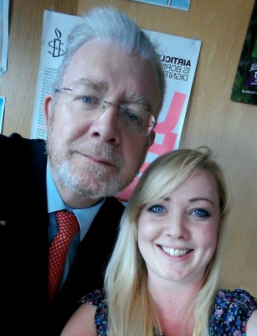
Edinburgh College chair Ian McKay said: “We’re immensely proud of ECSA and this new agreement demonstrates not just our faith in them but our wish to learn from them. They’ve proven to be tireless and effective advocates for our students and we’re supporting them to continue growing and developing their distinctive voice. The Board and college management need to have a robust, healthy relationship with our students’ association where views can be aired frankly on both sides. ECSA’s willingness to confer and consult with us - and strength of character to disagree with us - is both a tribute to their maturity and expertise and the bedrock for a healthy and honest future relationship.

“We’re thrilled that ECSA won the NUS award as we work very closely with the team and know how much they do behind the scenes to benefit our students. This is very much deserved.”

Cabinet secretary for education and lifelong learning Michael Russell MSP said: “I am delighted to welcome Edinburgh College’s steps to give students a powerful voice and enhance their influence over key decisions. A central aim of our college reforms was to put students at the centre, a promise we underpinned with legislation to increase their representation on boards and requiring institutions to have students associations.
“This announcement represents yet another step forward in strengthening the voice of students and I believe the college can only benefit from listening closely to the people who matter most.”
The agreement comes following ECSA’s award as the NUS College Students’ Association of the Year, which it picked up at the 2014 annual NUS Scotland Conference. The NUS Awards judges gave the honour to ECSA for its work over the last year, which includes vice president for women Katy Nixon’s efforts leading to a win at the NUS Scotland Women’s Awards as Inspirational Woman of the Year (a category that president Kelly Parry was also nominated in), and a win at the same awards in the Achievement of the Year for being the first college in the country to appoint a full-time women’s officer.

ECSA has worked closely with the college to help develop education provision, engaged students through a range of events and campaigns, provided opportunities through volunteering placements, and introduced new societies and sports clubs at the college to cater for students’ interests.

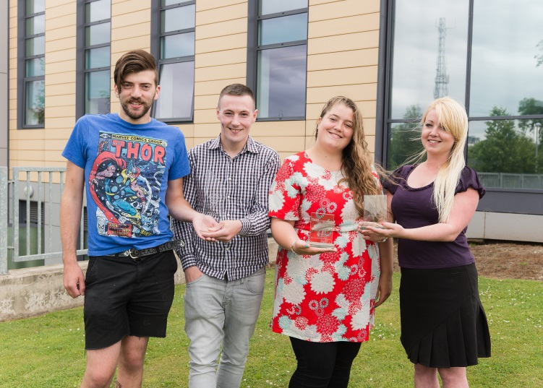
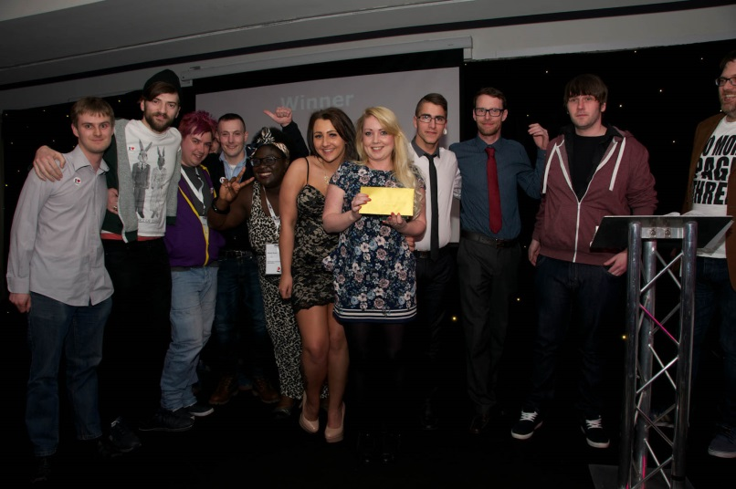
Although the college funds ECSA and works closely with it, it does not influence its ability to act as an independent voice for students and respects its right to disagree with the college and help find positive, common ground.
The 2013/14 Full Time Officers with ECSA’s awards: NUS Scotland College Students’ Association of the Year, NUS UK FE Union of the Year, and NUS Scotland Women’s Group of the Year

ECSA receiving the NUS Scotland College Students’ Association of the Year Award

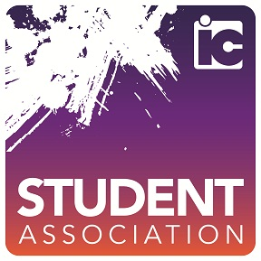Inverness College Students’ Association

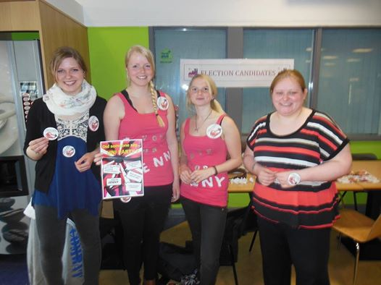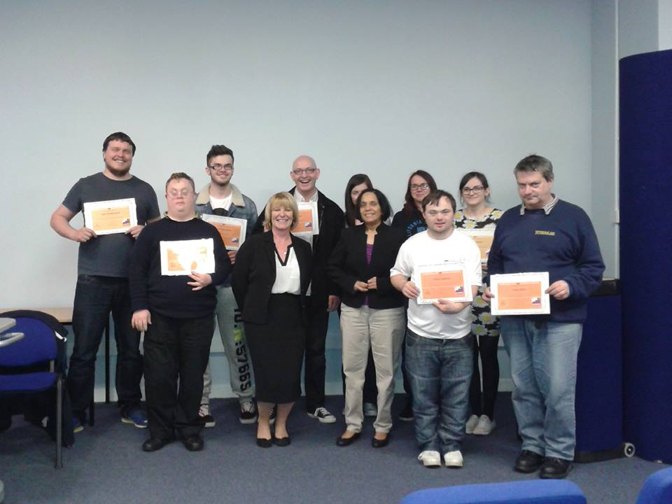
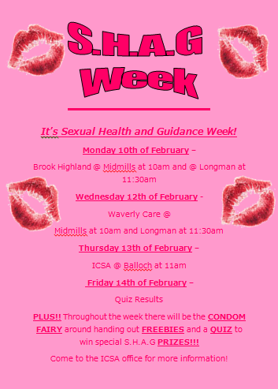
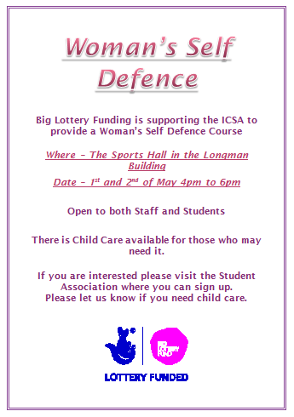
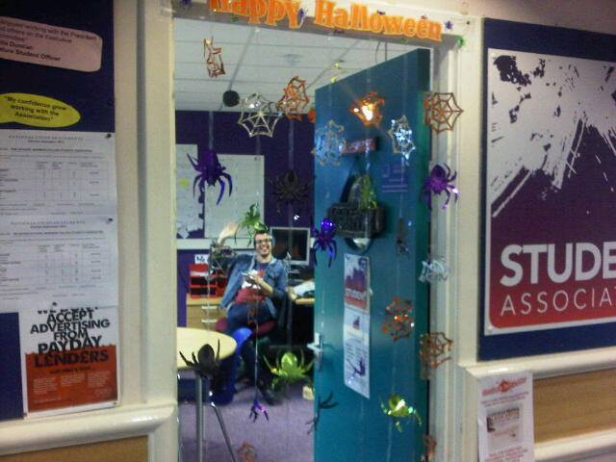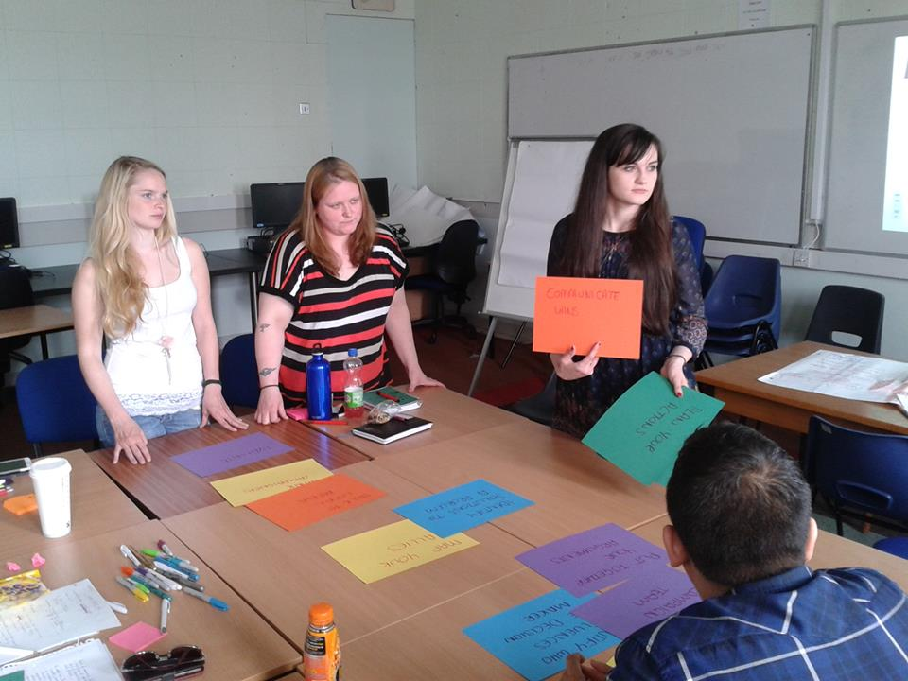
Sexual Health and Guidance Week
Campaign Training
Halloween
Woman's Self Defence
Jennie and Lizzie Campaigning
Class Rep Awards

New College Lanarkshire

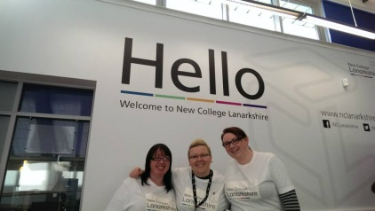
Mission Statement
Our mission is to:

Create an enriching and enhancing education experience for students in Lanarkshire and to liberate and empower students to engage in their own education through fair, effective and democratic representation.
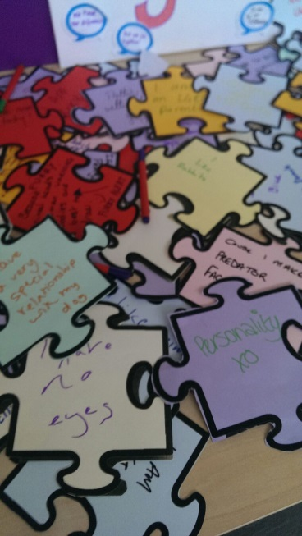
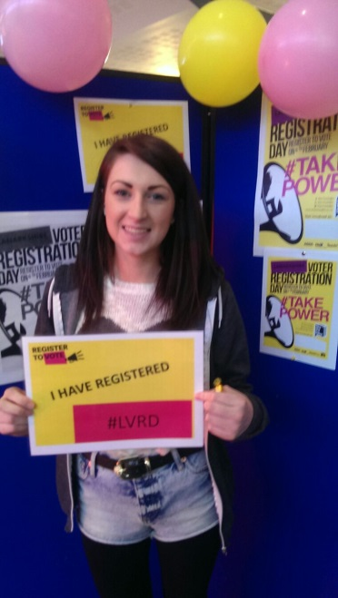
Diversity Week
Voter Registration
Vesting Day
Radio Show with South Lanarkshire

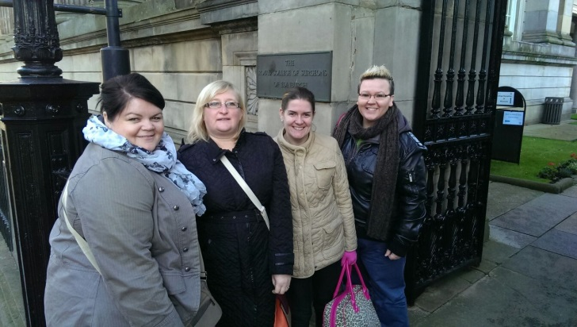
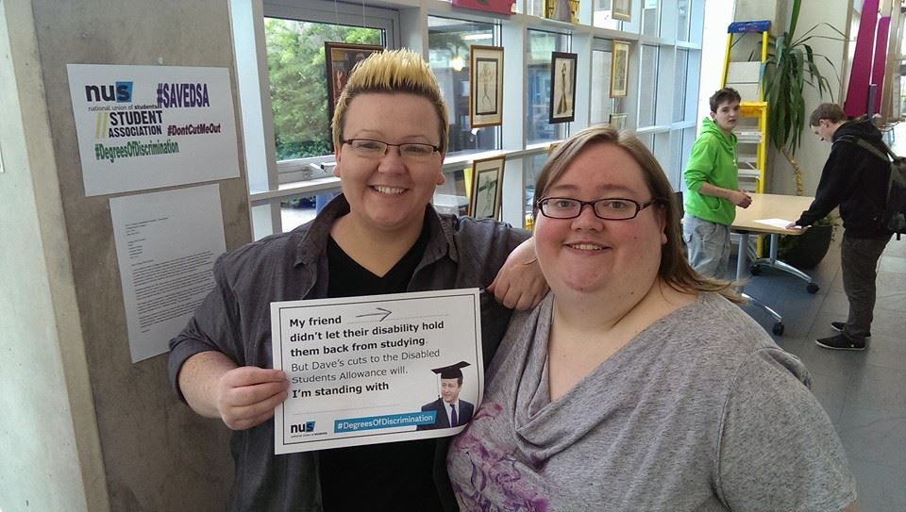
Lanarkshire Federation at NUS Scotland Zone
DSA Cuts Campaign

Quotes

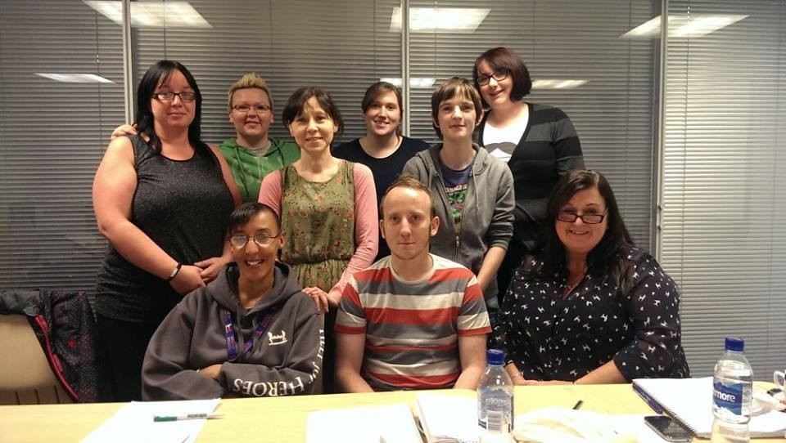
“This past year has been a difficult one for me with regards to health. I feel that I have had lots of understanding from my friends in the Student Association. I’m so grateful to have been given a chance to represent the students.” Louise Lamond - Kirkintilloch Officer

“The Student Association has had a big impact on me in the past year. I have become more confident, and my self esteem has been boosted massively. I have thoroughly enjoyed every minute with the SA, meeting new friends and being involved with the students is fantastic. It has given me a boost for my CV also.” Hayley Fraser – Charities and Events Officer
First Team Photo

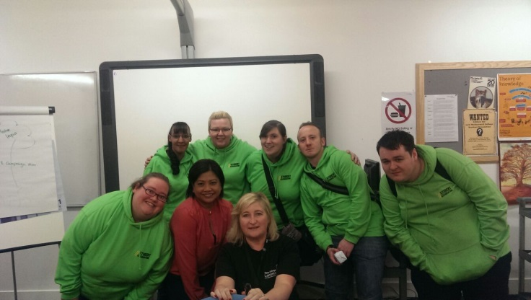
"This role has improved my skills and allowed me to take them further to a university level and my future career” Michael Ballantyne – Motherwell Campus President

“Being in the SA really made me feel like a part of the college. Taking part in events throughout the year was both fun and educational and gave me a real confidence boost. I took on responsibilities that I wasn't entirely sure I was ready for, but everyone was really supportive and I surprised myself with how much I am capable of. The opportunities for making new friends and having new experiences is endless, and I really value the friendships I made.” Jenna Reid – Former Vice President
Partnerships for Change Officer Training

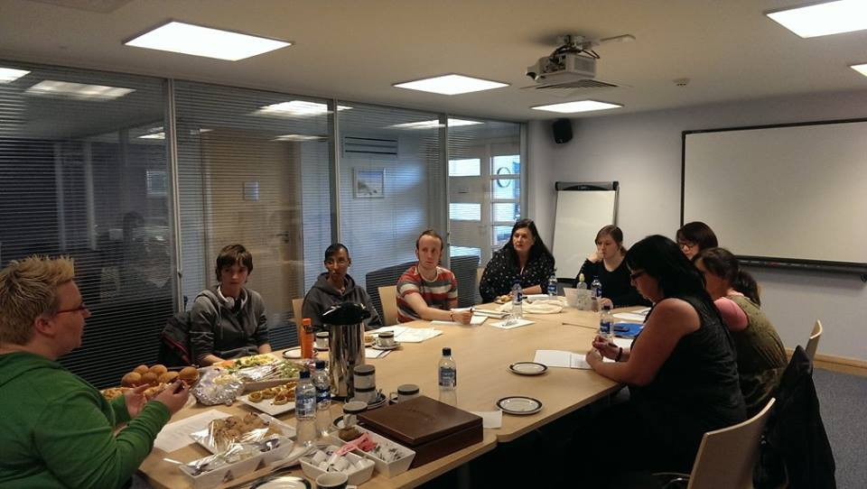
The effectiveness of the SA has been maximised through a well organised and committed SA executive committee led by the Student President. The work of the SA has been supported fully by college management, providing a Student Liaison Officer with 0.25 remission from teaching commitments to influence and direct the integration of the SA with college life and the requirements of the Education Scotland Quality Framework with its Learner Engagement key principle. Through the SA the learners have been involved in a wide range of activities including participation in decision making within college committees, effective class representation, social events integrating activities to challenge, raise awareness and to give opportunities for learners from across the college to mix (eg Diversity Week, Freshers' Week, Fun Day) and opportunities for learners and staff to discuss current issues within learning and teaching on an equal basis (Learner Conference). In the post-merger era SAs will face challenges equal to those faced by management and staff, but with the strength and experience built up over many successful years, the infrastructure is there to achieve success.
Our Very First SA Meeting
- Ian McCallum, Quality Manager

Fife College Students’ Association

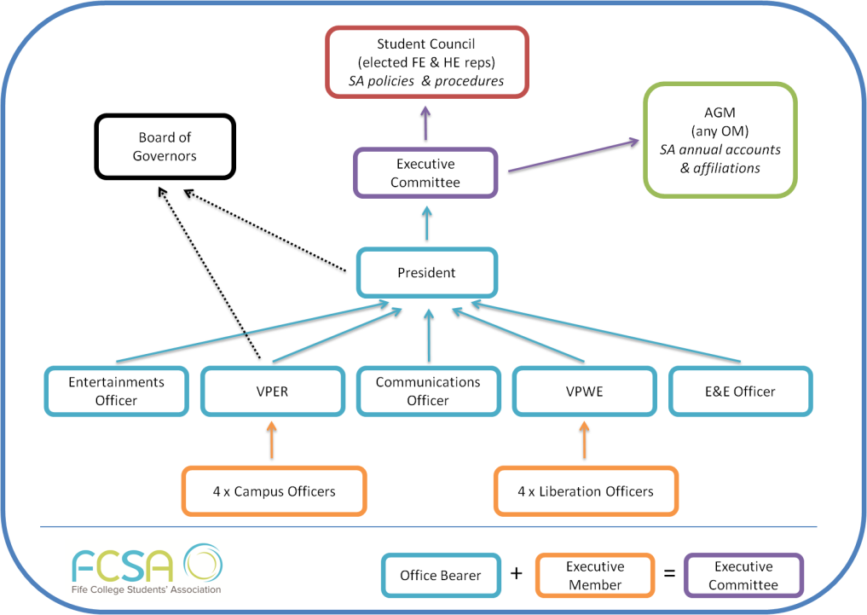
In 2014/15 Fife College Students’ Association will have three full time paid officers - President, Vice President Education & Representation and Vice President Welfare & Equality. They have an additional 11 positions on the Executive Committee which are all voluntary: Communications Officer, Entertainments Officer, Ethical & Environmental Officer, LGBT Officer, Women's Officer, Disabled Students' Officer, BME Officer, and four campus officers for the small under-represented campuses - Cupar, Levenmouth, Priory and Rosyth.
They are currently recruiting a General Manager for the Association

FCSA aims to offer a range of activities and events - social, sport, educational, awareness raising, RAG etc. each and every year. They are currently working on their new strategic plan, mission, values etc. This will be informed from the student consultation carried out January to March 2014.

Fife has continued to develop and build on their Communication Ambassadors scheme, which they began in 2012/13, and which has seen vast improvements. Communication Ambassadors are students recruited and trained by the students’ association to engage with students across the college.
This year their work was split into two phases. Phase 1 was November to January and informed the new Constitution (the key differences between Carnegie and Adam Smith, such as governing body, elections, positions). Phase 2 was January to March and used to inform the strategic plan as previously mentioned. Their work was invaluable. FCSA plan to recruit more in 2014/15 so we can gather student opinion on the SA and College changes.
At the end of the year, Fife College Students’ Association was shortlisted for and won the NUS Scotland Academic Representation Award.
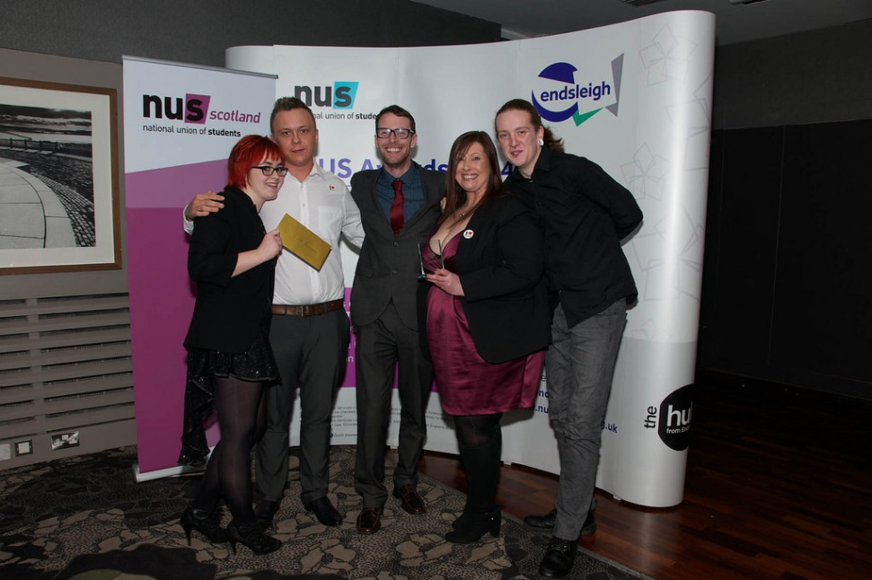

Ayrshire College Students’ Association

acsa Structures and Representation

We have:
- 3 full time Sabbatical Presidents, each representing a campus and a cross campus remit. These are: Learning & Teaching, Positive Wellbeing, and Community Partnership. Pre-merger, we had 1 fulltime sabbatical officer, 1 part-time, and 1 volunteer president. This approach supports a regional College structure
- There are 9 volunteer officer positions: LGBT Officer, Disability/Equal Opportunities Officer, Welfare Officer, Events/Fundraising Officer, Women’s Officer, Mature Persons Officer, Young Persons Officer, BME Officer, Sport & Physical Activity Officer.
- There are 296 Class Representatives across the region (AY 13/14.)
- Block grant maintained from previous year(£25k excluding Presidents salaries) , which was a considerable increase on the legacy grants
- New full time staff post dedicated to supporting the student association
- acsa have always had 2 Board members on the College Board of Management and this year the Board have granted a 3rd member to be given observer rights.
- New constitution in place
- Representation on learning and teaching committee, and other college committees and groups such as Equality and diversity
- Timetabled meetings with college managers and the Principal
- May election 3 three candidates, over 300 votes

Charity

This year Ayrshire College staff and students more than doubled their charitable donations compared to last year raising more than £20,000. The acsa played a major role in this figure.
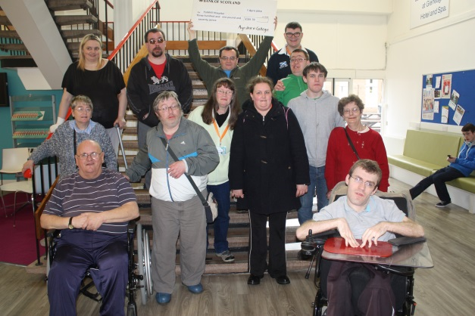

Wear it Purple (Mary in the middle) Over £300 raised for Yorkhill Hospital by one of our Supportive Education classes
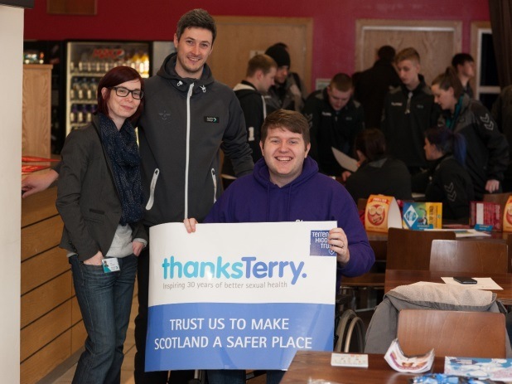

Charity Football for Terrence Higgins Trust

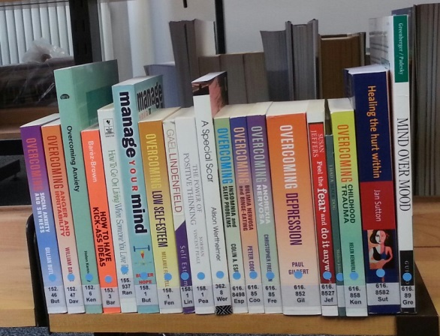
Student Wellbeing

The SA was instrumental in promoting students positive mental wellbeing, with developing and delivering workshops to staff and students on the topics of Mental Health, Self Harm and Anxiety.

Also with consultation of the QMU, a bibliotherapist and councillors acsa introduced the very first bibliotherapy section within a library of a Scottish College.

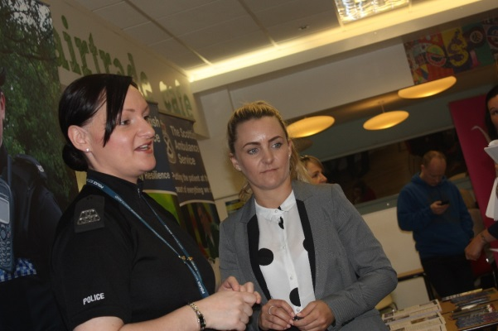
Partnership working with Police Scotland and NHS in the shape of Ayrshire Colleges’ joint posts for a Campus Liaison Officer and Addictions Liaison. Together we ran respect week with lots of workshops on drugs and alcohol, personal safety, and road safety. Over 1300 students took part and 96% stated they were very satisfied that the relevance of the topics delivered to them during Respect Week and that it contributed to keeping people safe. Our external partners were happy too.

Marie Wilson, NHS Addiction Education & Prevention – ‘This week has been amazing, lots of interested enthusiastic students.’

Equality Week

A very successful Equality Week. The acsa arranged for Who Cares Scotland to attend and also speak to staff regarding Corporate Parenting, again the first college in Scotland to have staff made aware of their Responsibilities.

Equality Week compromised of a market place with stalls and an on-line campaign named #iammorethan which encouraged people to take a selfie and post it with a hashtag that they felt they were more than in order to challenge opinion and thoughts. acsa provided a prize for a random winner of the submitted selfies. acsa also organised a careers fair with a number of students directly gaining employment from this.

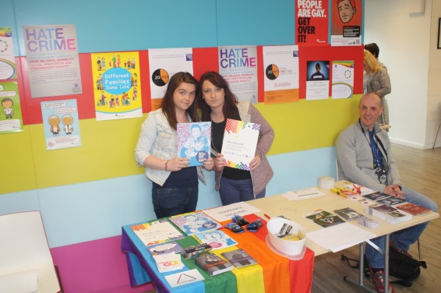
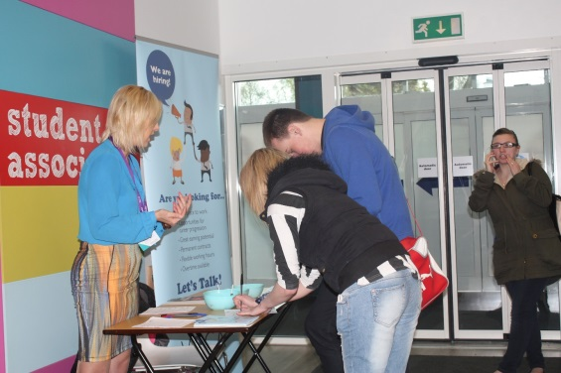

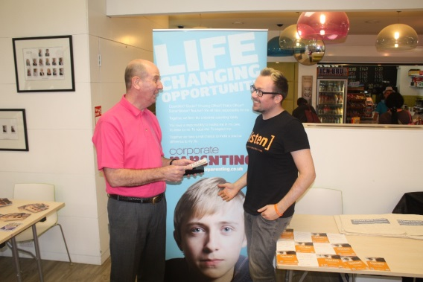
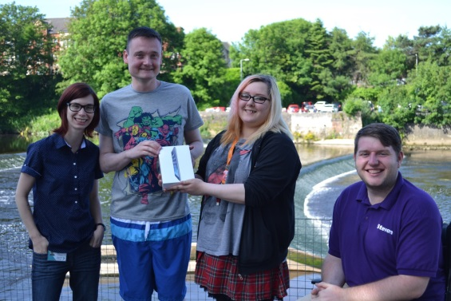

Ayrshire Colleges’ Access and Inclusion classes held an end of year sports day which acsa took part in and helped publicise.
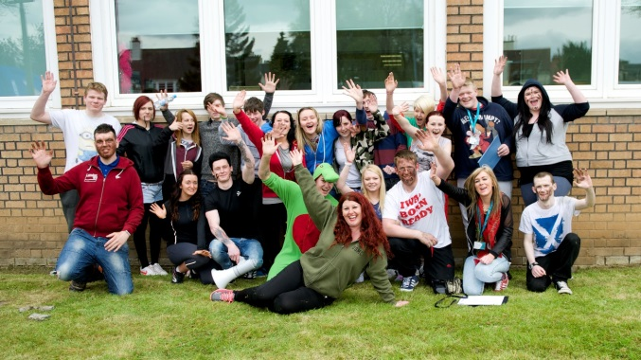
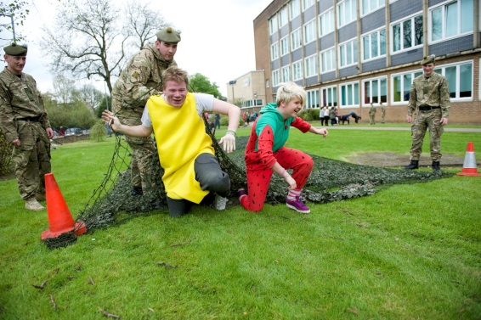

White Ribbon

In order to challenge opinion and ideas of violence against women a member of acsa, along with college staff attended speaker training for the White Ribbon Campaign. This resulted in a range of activities such as: The “signing of the pledge” in a more creative way as seen above, workshops,
and “The Real Man Box” to name a few. This was where students were given the opportunity to say what a real man was to them, above is one example of the feedback.
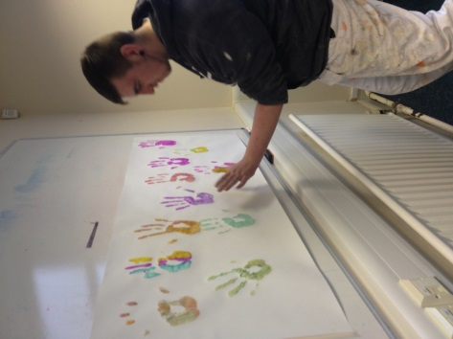
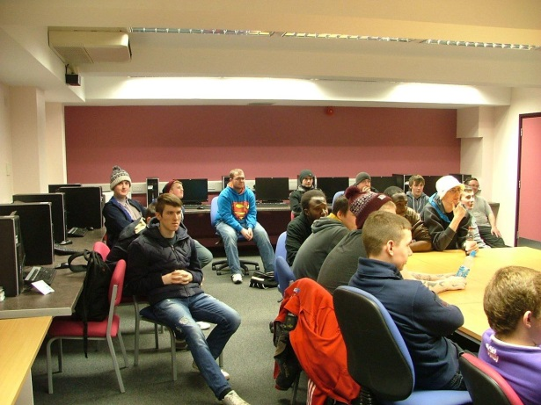

Quotes

“Hi, I’m Angela and I’m a previous Sports student of Ayrshire College. As a Student President my role is to represent the students of Ayrshire College and to be a voice for them. Coming to college has been life changing for me. I have been given opportunities and experiences that I never thought possible. My aim is to ensure the students have the same opportunities and experiences I have been fortunate enough to receive in my two years at college.”
Angela Alexander acas Student President (Community Partnership)

“The students association has played an extremely important part and has had a huge impact on me during my first year of studies. If it wasn’t for the Ayrshire College Student Association I wouldn't have been able to complete my studies and be as successful as I believe I am right at this moment in time.
The Association allows students to access so much support, for so many things, whether it be personal or class related. There was so much support, services and information that the students association can provide and you are always guaranteed a friendly face.”
Steven Connelly, Media Student, Ayrshire College

“The new Student Association has quickly become integral to the life and work of Ayrshire College. As well as influencing decisions on learning and teaching over the last year the association has made a significant contribution to the wellbeing of students and to the wider community through their charity events. The Association has taken student representation and engagement forward and is working in partnership to deliver an excellent student experience”
Helen Canning Director of Student Services Ayrshire College

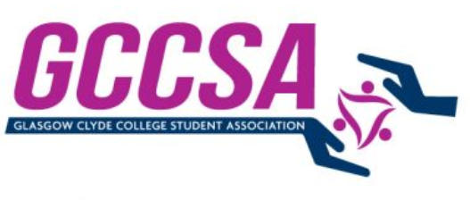
Glasgow Clyde Students’ Association

VIP (Volunteer, Intern Partnership)
In the short period of time that Glasgow Clyde College Student Association (GCCSA) has existed. The Student Association has sought to find new and inventive ways to improve the student experience. This has mainly centred round developing skills for students to improve their employability by working in partnership with Glasgow Clyde College (GCC).
Student Elections were held in May 2013 a Vice-President for Activities and Development was elected. The manifesto, on which he was elected, was to improve employment opportunities for the students at GCC. Following a successful election campaign and being elected into the position of GCCSA Vice-President created a project group to help deliver the objectives in the manifesto under which he was elected.
A project group was set up who met on a fortnightly basis, with the GCCSA Vice-President leading the group. The group consisted of members of staff from within the College who had relevant skills and expertise in a wide range of areas. From this the concept of Volunteer Intern Partnership (VIP) was developed.
VIP is a joint project run by GCCSA and GCC which aims to provide students with a one stop shop for volunteering and internship opportunities. A number of local organisations were invited to attend an event within the College, giving organisations information about VIP and how they could become involved in VIP by becoming a key partner.
A key partner is an employer or voluntary organisation able to offer internship opportunities to GCC students. In becoming a key partner organisations are able to support the development of Scotland’s future workforce whilst supporting a student’s development.
Currently further funding is being sourced in order to progress the VIP project further, but it is hoped when the funding is secured VIP will become an integral part of both GCCSA and GCC
‘VIP is an inspiring scheme that has been developed to enhance the employability of the College’s students, giving them invaluable industry experience that will help enhance the economic future of Scotland.’ Susan Walsh, Principal of Glasgow Clyde College
‘The Student Association are excited about the VIP programme and the opportunities it will open up to our students. We look forward to engaging with key partners to enhance the employability skills of our students.’ Barclay McCrindle, GCCSA President.
Volunteer Fair
Glasgow Clyde College Student Association (GGCSA) has become aware of a number of students approaching themselves and the College in gaining work experience through volunteering. As a result of this GCCSA decided to organise a Volunteer Fair for students at the College to allow students the opportunity to explore the volunteering opportunities on offer to them.
In February of this year Glasgow Clyde College Student Association (GCCSA) held the First Volunteer fair at Glasgow Clyde College (GCC). This was a three day event with a day at each campus.
Over 53 organisations attended the volunteers fair at the College, from a wide range areas including: health & wellbeing, community development, animal charities, international NGOs, environmental charities, educational charities.
Several students volunteered with GCCSA to help to collate information from all those that attended. The feedback received from the Volunteers Fair was both positive and encouraging from the students and organisations which attended.
To date 132 students have gone on to volunteering positions within the organisations that attended. This experience will enhance there future employability and look good on their CV.
These placements also raise awareness of social responsibility amongst GCC students.

West College Scotland Students’ Association

Health and Wellbeing
In the formation of West College Scotland Students Association we decided that if we were going to put the fun back into being a student we had to also set out to look after their health and wellbeing to which in turn led to the creation of our health and wellbeing teams.
These teams were made up of highly committed students that underwent a lot of extra training provided by external agency’s to help them provide reliable accurate and useful information in the areas of sexual health and Alcohol Awareness and safety. In this coming academic year we plan to further develop the Officer position to include assisting our on campus counselling service and also Drug misuse.
- Provide Confidential sexual health advice / Clinic Referrals
- Provided over 5000 units of contraceptives
- Worked with Local Authority’s to provide workshops
- Sex and Alcohol Safety Talks (Usually before event nights)

Charity Events

WCS-SA ran many charitable events this year that have helped benefit not only national causes but also local causes. This year our Current officers have tried to install the notion that going above and beyond yourself to help and assist individuals in need is an overall great thing, and if there is one thing I hope to leave at WCS SA for the generations of officers that will come after me is the great commitment and enthusiasm we show at providing support to our local and national charity’s.

- Inverclyde Food bank – This year the teams across the college ran collection stations for our local food banks. These stations were very successful and over the entire region our student contributed 100 bags with the greatest number coming from the Greenock campus. In the coming Academic session we will be running the collection stations again with the hope attaining over 200 bags.
- Anti-Knife Campaign - One of the Causes that was carried over from our old Association was providing support to our local anti-knife campaign, this has seen team members taking part in promoting the dangers of Knifes to the local community’s.
- Spina Bifada – A campaign was run by the Greenock campus team in aid of promoting spina bifida and the students also managed to raise £310 over the two days the event lasted.
- Sweet Stands for Starlight - This year WCS SA set up sweet stands around our campuses to assist in raising funds for the Starlight Charity. To date over £700has been collected and donated to the Charity.
- Stand Up to Cancer – This year the Association assisted the Marketing department in promoting the stand up to cancer campaign. This saw the campus teams selling specially made calendars to students and staff across the college.
- Children In Need- Students at our Greenock campuses managed to raise £510 in the week leading up to the event.

This list covers the events that were set up and run by WCS-SA, throughout the year we provided support to students that were running their own events.

Student Nights Out

At West College Scotland Students Association we still believe that during the hard economic times we are faced with students still need to have fun. So WCS-SA under took and ran a vast number of Association led events to help put the fun back into being a student.

We strived hard and tirelessly to obtain discounts and offers that would benefit our students and their social life’s. The following Bullet points will highlight some of our key events that happened throughout the academic year.

- Refreshers Night – After the biggest Fresher’s event undertaken at WCS we planned and organised our Refreshers night. WCS-SA managed to work out a deal with Re-Play Glasgow which would supply us a house DJ as well as accommodating our own DJ, They also gave us a great deal on alcohol for the event and they were selling drinks at £1 each. Our night was a great success and we had more than 250 students in attendance
- Disabled Student Events - This year WCS-SA focused a lot of attention onto providing our students that suffer from Physical and mental disabilities with the same opportunities for evening events as our able bodied students. Throughout the year we ran three Student Disability Discos at Clydebank campus and with the assistance of Senior Vice President Johnpaul Johnston we assisted on the of a safe environment disco in partnership with the Arches Glasgow, these events were well attended by many of our students from the whole college
- Xmas Bash- This event saw us return to Re-Play Glasgow and had number well over 300
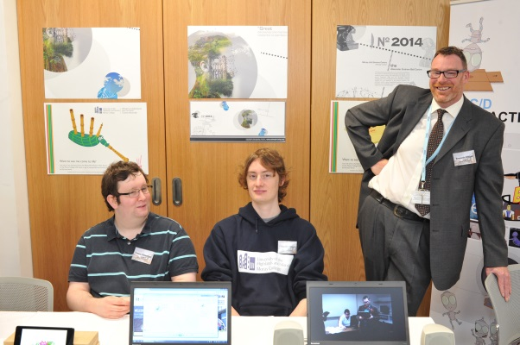
Moray College

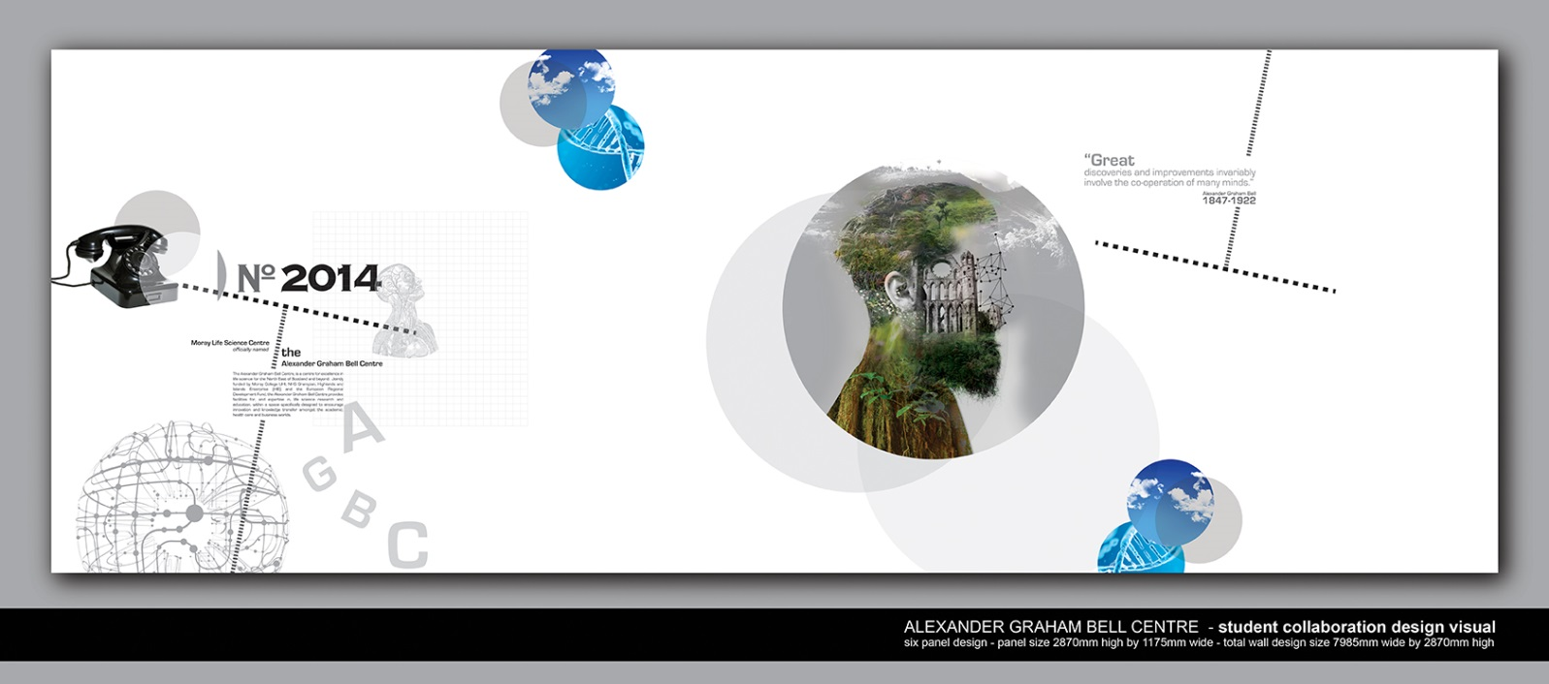
This photo portrays two out a group of students who were part of a project group to create art for our new Life Science building at Moray College UHI Elgin. The new building is named after Alexander Graham Bell, therefore the Abstract Art image enclosed includes telephone and the cathedral in the town of Elgin where it is thought he first had the idea for the telephone. This was showcased to Princess Anne who opened the building on 27th June.

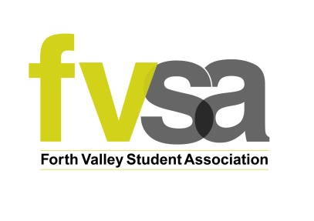
Forth Valley College Students’ Association

Forth Valley has recently successfully applied for funding from the Scottish Funding Council to enable them to strengthen and develop their students’ association. The Sabbatical President and two of three Campus Vice Presidents have been elected, and new students’ association staff member recruited.

“As a non-merging regional college we were extremely pleased to be allocated funding from the SFC this year which will enable FVC to establish a fit for purpose Student Association. In a short space of time SPARQS guidance and support as part of this change has been invaluable and has enabled FVC to move forward in confidence for the start of the new term with a new Student Association”.

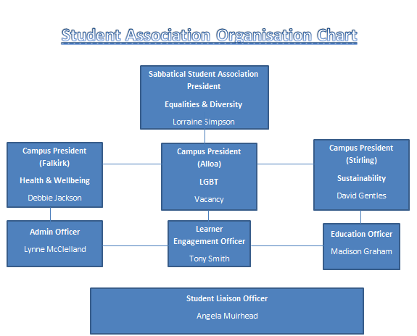
Jean Duff, Student Services Manager

Perth College Students’ Association

We have lots of examples of successes achieved by our Students’ Association, but we are particularly proud of the following:

OBI Awards (Outstanding, Best, Inspiring)

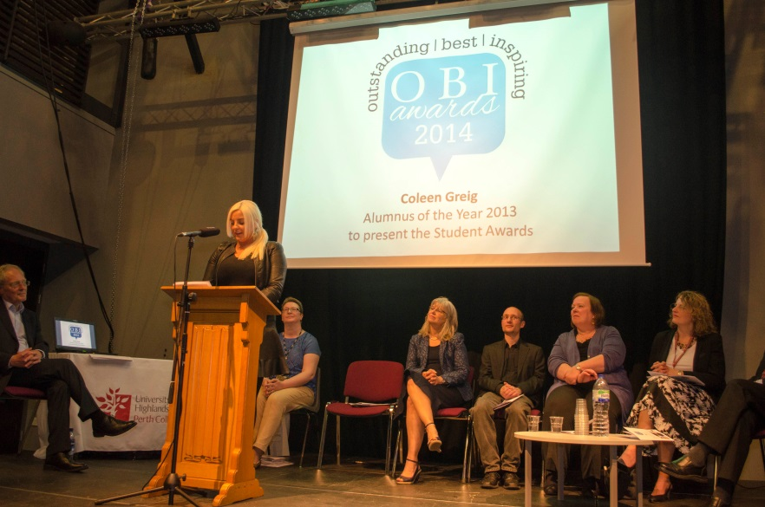
These awards allow students to recognise the staff and students who make their experience of College life so great.

Categories of Award are:
- Most Inspiring Lecturer
- Best Personal Academic Tutor
- Award for Outstanding Support Staff Member
- Most Significant Contribution to Quality Enhancement
- Student Representative Council Award for Student Engagement
- Best Student-Led Event
- Most Improved/Developed Club/Society
- Best Overall Student Rep

Introduced in 2012-13, these awards are organised and funded by the Students’ Association, with the support of a cross-college team.
Our first keynote speaker was NUS Scotland’s Vice President (Education) Graeme Kirkpatrick, who spoke about how important it is for Student Reps to feel that they are making a difference, that their opinion matters and that: ‘their voice is heard by staff who understand that they are the experts on their own experience at College and that together that experience can be enhanced and improved’.

The awards were run again in 2013-14 when the keynote speaker was a former Alumnus of the Year, Coleen Greig, who spoke movingly about the opportunity that Perth College UHI gave her to switch from a Maths degree to study Aircraft Engineering and how the staff and student reps made sure that her experience in College met her needs, allowing her to secure a job in the oil industry and continue her studies to PhD level.

Scottish Independence Referendum Debate
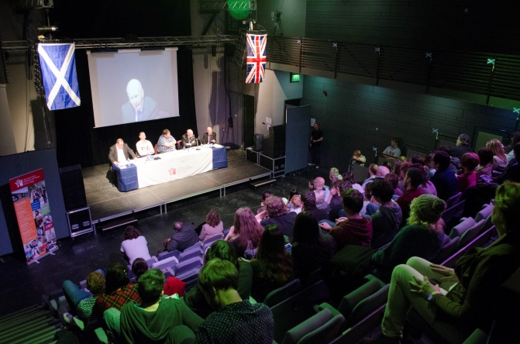
The Students’ Association led a cross-college team to organise and host this event on the 30th April 2014, providing a platform for an informative, concise and lively discussion which allowed the student population on campus to engage and connect with the big issues which will affect them for the rest of their lives. Held in the Goodlyburn Theatre on Campus, the event was also open to the public, with places booked on EventBrite.

The event culminated in a vote to see if the audience had either decided how to vote or had changed their minds about how they would vote.

Student Elections

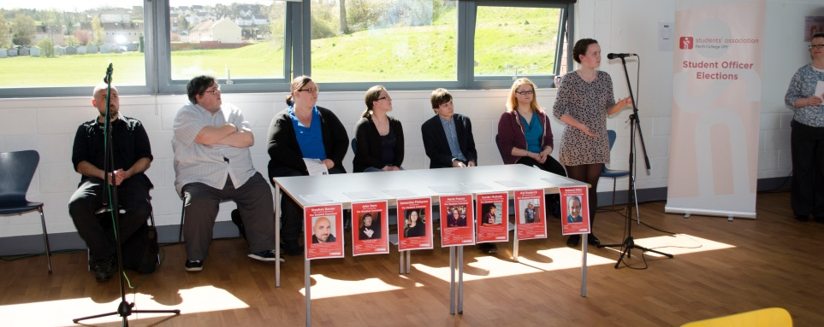
The latest Student Elections took place in May 2014 and saw 5 new Conveners appointed in a contested election, with a remarkable 13% of the full-time student body voting. The Students’ Association worked with the Returning Officer, Head of Quality Alison Clark, in ensuring that a fair and transparent election was held, using the postal vote process and real ballot boxes as recommended by our local electoral registration officer. Staff and Conveners rallied round to man the polling stations for 80 man-hours over the voting period to ensure that students had the opportunity to meet the candidates, check out their manifestos and cast their votes.

For many of our younger FE students, this was a good example of a real-life election experience that will encourage and prepare them to make their voice heard in the upcoming Scottish Independence Referendum.

College Open Days
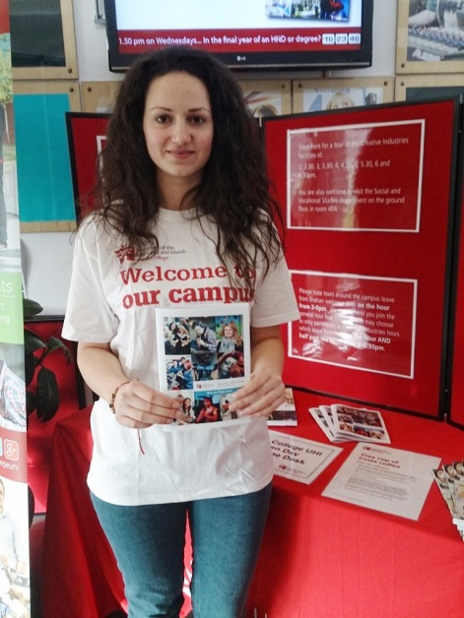
The Students’ Association Conveners supported our College Open Days, enthusiastically telling potential new students and their families what it is like to study at Perth College UHI, as well as handing out information packs and goody bags and conducting tours of the Campus.

City of Glasgow Students’ Association
The below is taken from City SA Highlights, the preparatory document to the Students’ Association’s 2013-14 Annual Report. The full report is available from sanjay.lago@cityofglasgowcollege.ac.uk or http://www.citysa.co.uk/representing-you/annual-report.html
Student President 2013/14 Gavin Quinn:
“CitySA has developed massively over the past 3 years and is set to keep improving exponentially. The days of taking baby steps are long gone and we’ve moved onto taking giant leaps and bounds to better the Students’ Association and the lives of our students.”
Student President 2014/15 Sanjay Lago
"Having been part of the SA now coming into the 4th year, being the current president I have been able to see the SA grow and grow and I am excited to take this path that has been constructed further and into a longer path and legacy at City of Glasgow College. It is an exciting year with new members arriving and new ideas growing, and I look forward to being part of it all and the voice of the students at City of Glasgow"

Students’ Association Liaison Officer Thomas Crawford:
“Student-staff partnerships are an integral part of a successful college. They ensure that fresh ideas, learning experience and expert knowledge all combine to keep standards high. CitySA promotes student ownership and active participation. It empowers students to believe they can action change both inside and outside of college.”

Highlights of 2013/2014
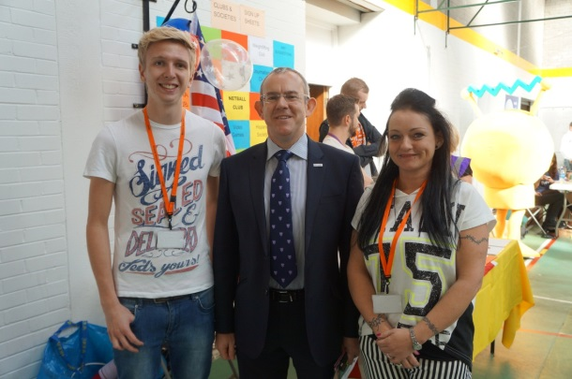
CitySA have made huge strides this year, expanding their ambitions further than before and making a significant impact across the college. This has been a bumper year for the Students’ Association with many success stories and some of our highlights are listed below:

Freshers’ Week
CitySA welcomed new students and returning students alike this year with a hotly anticipated two-day Freshers’ fair. Opting for an American themed event - with cotton candy, Krispy Kreme, retro memorabilia and more - this welcome party was large, brash, vibrant and colourful in a very American way and got the year off to a flying start.
Stands available for students to visit included:
- Scottish Political Parties
- Local Trendy Bars and Eateries
- Dentist, Gym and Bank
- College Support Services
- Representatives from Better Together and Yes Scotland
- LGBT Youth, College LGBT Society
- Various Charities including Amnesty, Epilepsy Scotland and WhoCares
- NUS Scotland
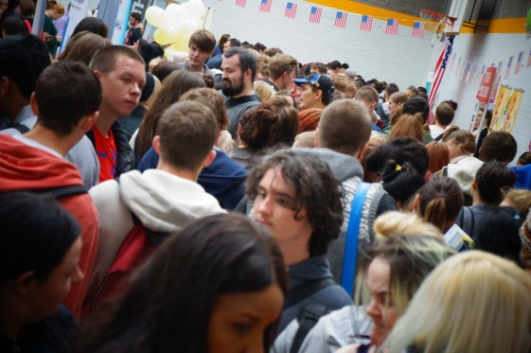
Over the two days which Fresher’s took place thousands of students got involved with shuttle buses in place to ensure the event was accessible to all campuses. It was an exciting start to the year for both the Students’ Association and student body and visitors were welcomed with entertainment, information and lots of freebies.

Class Rep Push
The most important part of a strong Students’ Association is an active student base. Class Reps are CitySA foot soldiers: they are leaders on the ground. This year the Students’ Association have invested in building their numbers and enhancing their capacity. With more class reps than ever before, and over 280 fully trained, CitySA had a fantastic foundation this year to build its many successes.
This year saw the Students’ Association adopt an exciting new approach to training class reps with former class reps empowered to lead on delivering training. Previously training had been delivered by external practitioners but the new system allows for a more tailored experience with bespoke training delivered by trainers who understand the college. All class rep trainers are still fully briefed and prepared by Scottish Participation in Quality Scotland (sparqs). This new approach has proved very successful as can be seen from the evaluation table.

Inspire 2013
To help fully prepare class reps for their roles, CitySA organised the college’s biggest ever class rep event back in December. Inspire2013 set a new precedent for years to come with class reps from across the college coming together to listen to inspirational speakers at Cineworld cinema in the city centre. This Class Rep extravaganza thanked class reps for their commitment and helped encourage a genuine spirit of activism amongst students across the college.

Student Elections 2014
This year CitySA looked beyond the campuses of our college to advertise elections citywide. An innovative partnership was agreed with neighbouring institutions Strathclyde University and Glasgow Caledonian to enter into a collaborative venture called The Big Elections. This enhanced the elections process in several ways including:
- Raising thousands of pounds in sponsorship for the Elections
- Advertising the elections externally on Capital Radio and the Glasgow Underground.
- A longer voting period than ever before (five days allowing more students to have their say)
- A record number of students voting
- A larger, more exciting announcement event at Strathclyde Union alongside Strathclyde and Glasgow Caledonian
- Elections results streamed live across the internet

Annual General Meeting
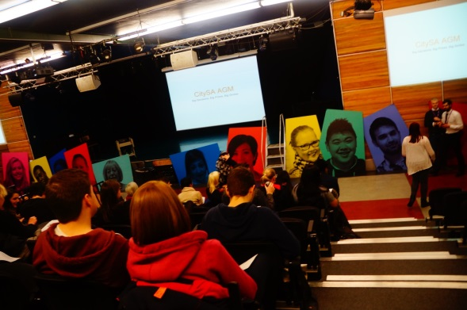
Effective representation needs accountability and a chance to collectively discuss important issues. This year CitySA successfully held the Students’ Association’s first ever AGM. A strong turn-out from students meant that motions were discussed and voted upon and that the democratic nature of the Students’ Association was strengthened in the process.
The following motions were discussed:
- Motion to allow two-term sabbatical officers
74 x Yes & 2 x No
- Motion to look into full-time Vice-Presidents
- Yes & 35 x No
- Motion to allow easier CitySA Sponsorship
69 x Yes & 7 x No
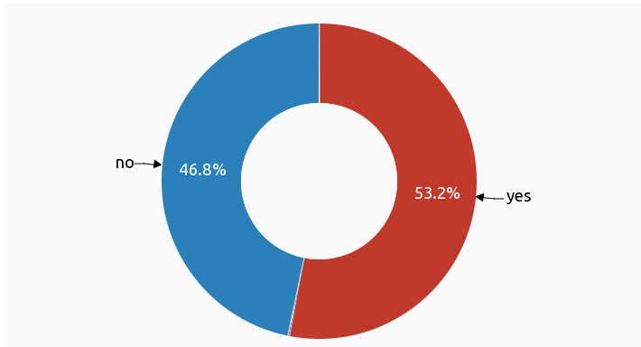
Independence Week
With the Scottish Independence Referendum approaching, CitySA embraced the responsibility of informing students about this epoch-defining choice. The Students’ Association worked hard to organise an online referendum and the response from our students was fantastic.
Over a thousand students at the college voted in the CitySA Independence Election which was narrowly won by a yes vote. In total, there were 1070 votes with 569 students saying yes and 501 students saying no. The table below illustrates the split.
The announcement of the results for this referendum made an incredible impact when released and became our most popular social media post ever. The graph above with accompanying text was shares 330 times, like 1,645 times over all shares and was seen by nearly 30,000 people. The Students’ Association are proud to have encouraged students to engage with this important decision and also give them a platform to express their views.
2012-2013 | 2013-2014
NUS Gathering Conference | NUS Gathering Conference
NUS Governor’s Training | NUS Governor’s Training
NUS Scotland Zone Conference | NUS Scotland Zone Conference
NUS Scotland Conference | NUS Scotland Conference
NUS LGBT Scotland Conference | NUS LGBT Scotland Conference
NUS Parliamentary Reception | NUS LGBT UK Conference
 | NUS Black Scotland Conference
 | NUS Black UK Conference
 | NUS Woman’s Scotland Conference
 | NUS Officer Bootcamp
 | NUS SocCit Zone Conference
 | NUS UK Conference

National Presence
The Students’ Association have pushed harder than ever this year to be an active part of the National Union of Students (NUS). With more students at the table CitySA will have a greater input into national debates, a greater say on how national policy is shaped and greater working relationships with other institutions.
This year student representatives from City of Glasgow College have been sent to double the number of NUS conferences and events as they did in 2012/2013. This has already paid dividends with next year’s student President being elected NUS Black Officer for Scotland and one of the college’s students being elected onto NUS UK LGBT committee.

Regional Board
The CitySA Student President was appointed as the first ever chair of Glasgow’s regional student executive. The Student President will be holding the first meeting of the regional student executive at the end of May 2014 with elected student officers from City of Glasgow College, Glasgow Kelvin College and Glasgow Clyde College.

NUS Awards
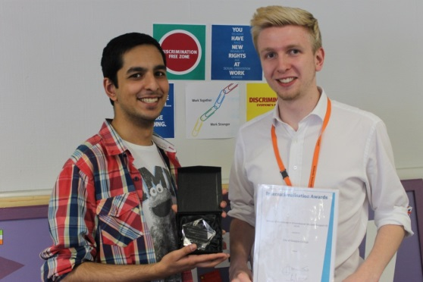
With such a busy schedule, the CitySA team rarely get a chance to take a step back to appreciate all the work that they have put in over the year. However, NUS gave the team this opportunity when the Association was shortlisted for Scottish and UK-wide awards. One reward in particular noted the fine accomplishments of both the college and the CitySA team. All details are listed below:
NUS Scotland Awards:
- Nominated for College Students’ Association of the Year
- Nominated for Innovation & Enterprise
- Nominated for Staff Member of the Year

NUS UK Awards:
- WINNERS of Excellence in International Student Support FE

For CitySA to gain this level of recognition is a fantastic honour. It shows that both the Students’ Association and the college value international students and the contribution they make to both education and society. It is with great pride that CitySA Student President and President Elect received this award to lead the way for all colleges in Britain.
Conclusion
CitySA have had an extraordinary year, making advances across the board, showing the true strength and capability of the Students’ Association. This report has given a glimpse of the big successes of the year and the full extent of the association’s achievements can be found in the full CitySA Annual Report which will be released before the end of term.
CitySA are incredibly proud of what has been achieved this year and have set an incredibly high standard for years to follow. The current team wishes the team of 2014/15 the best of luck and look forward to seeing the Students’ Association move forward, achieve more, action positive change and give the students of City of Glasgow College the best college experience imaginable.

Dundee and Angus Students’ Association

Summary of office structure and remits

- The Student President is directly elected by students from across the college. The Vice Presidents are directly elected by students from their respective campuses. In the latest elections (April 2014), almost 600 students participated in this process, compared to a historic college sector average of 200.

- The President (a paid full-time sabbatical role) will act as a voice for the student body. They will travel extensively between campuses to ensure effective communication between the students, Students’ Association, the Board of Management, local and national Government bodies and other groups as the student body sees fit. In partnership with the Vice President and the Learner Engagement team, the President will ensure that our students are well represented in all decision making processes relating to their learning and the life of the college, in addition to supporting engagement activities and the enhancement of the learner experience.

- The Vice Presidents (a paid part-time sabbatical role) will support the President in ensuring effective communication. They will also play a key role within their designated campus, but will also travel between campuses, to support student representation, advocacy and engagement activities.

- Moreover, these elected officers will have seats on the college’s main boards. The President (as mentioned) will liaise with the college Executive (the Principal and, in particular, the Assistant Principal for Planning and Performance). In addition to that, each of the officers will sit on various committees in the areas of: Curriculum, Quality Enhancement, Equality & Diversity, Health/Safety/Wellbeing and ICT.

Summary of staff support
- Dundee and Angus College has greatly and generously invested a lot of money in expanding the Students’ Association, in order to entrench it as a valuable and effective part of the overall college structure.

- As part of this, each of our three campuses will have a full time Learner Engagement Officer, who will be based at the Students’ Association office. Their role will be to support, guide and advise the student officers.

- We also have a Learner Engagement Manager, whose job it is to oversee the work of the Engagement Officers. However, being an autonomous body, the Students’ Association works in conjunction and liaison with the Learner Engagement team, although is not directly accountable to them. The Manager’s main role in terms of working with the SA is playing a lead role in the development of learner engagement systems, arrangements and activities. They will support student representative arrangements, acting as a further mentor to support, guide and advise student officers.

- Assisting with the newly established Sports Union, there is now a full time member of staff (a Sport and Wellbeing Officer) whose job it will be to promote student participation in sporting events, and to raise awareness about both physical and mental wellbeing.

Summary of structures
- Currently, the structure of representation at Dundee and Angus is undergoing a comprehensive re-evaluation; representation and feedback mechanisms are being restructured in order to accommodate the new merged college, which brings together two very different cultures.

- At the moment, the structures include class and lead representatives from across departments, and focus groups and college surveys. Engagement levels and methods vary across the campuses.

- As we look at developing our representative structure, we will also be looking towards facilitating more flexible outlets for feedback and engagement – looking at a number of different methods to allow for full participation with the process; having students as partners. This will give students ownership of what they’re doing.

- Part of the representation restructure includes developing a new format and branding for the SRC, including the Student Executive and elected representatives.

- Campaign Officers (a voluntary position with opportunities for accreditation) are created by the Students’ Executive to support the activities of the SA. Any student can be a campaign officer, working with the SA to promote a cause, event or activity.

- Campaign officers – being unelected – would not be eligible to be members of the Students’ Congress, but would be welcomed to advise the Student Executive on different campaigns and issues of advocacy.

- The Student Executive comprises a President and three Vice Presidents (one from each of our three campuses). All of these posts are directly elected by student body and are accountable to them.

- There is also a Sports Union, which is a newly established arm of the Students’ Association.

- Many structural areas are yet to be finalised and are provisional at this stage.

Main areas of activity

Representation; Welfare and support; Social, leisure and sport; Enterprise and volunteering

Main priorities for next year
- Each elected officer at Dundee and Angus College will have their own individual projects to undertake throughout the next academic year, as well as all working together on combined projects.

- Student President will be focusing on promoting civic engagement in the college, encouraging students to register to vote and to participate in socio-political campaigns about any issues they have passion for. This will be accommodated in part by the aforementioned Campaign Officer roles, as well as a political awareness group which will be set up in conjunction with a member of the Dundee Youth Council. This will be manifested in the form of a Referendum debate and then a General Election debate to which all parties/campaigns will be invited.

- The Vice President at the Gardyne campus will be looking to engage with community education and community organising. He will be establishing links between the college and local charity/youth groups, encouraging students to participate with these organisations. This will boost students’ added value activities, and feeds into the ‘responsible citizen’ aspect of the Curriculum for Excellence.

- The Vice President at Kingsway campus, who has been re-elected, hopes to build on his efforts last year in attaining a bronze Green Impact award. Already, he has most of the boxes ticked for the silver award, and the Students’ Association this year will again be keen for this to be achieved. In conjunction with the President, they are looking into working with

- The Vice President at Arbroath campus hopes to raise awareness of the effects of alcohol. They will also be looking at working in conjunction with the Sport and Wellbeing Officer to establish an inter-college charity competition. This would be tied in with the Movember campaign.

- The Sport and Wellbeing Officer (a staff post) aims to promote participation in sporting activities, as well as increasing the recognition of such activities at the college. He seeks to formalise the competitive angle of sport, and promote sport for recreational use too. This will allow students to volunteer with the newly established Sports Union. Part of how he hopes to achieve this is by proposing an inter-college Varsity competition event.

- The recent HMI review at Dundee and Angus reminded us that more work has to be done to engage students with SA activities – particularly at the Kingsway campus. The Vice President is aware that there is an issue to be addressed, but the SA is looking at ways to do so. Part of this includes regenerating the space we have at that campus, by transforming it into a multi-use area, in order that an array of students will be attracted to coming along. This will include a student-run shop, which Arbroath already has, designed to boost entrepreneurialism in the college (the shop idea will be replicated at Gardyne too).

Students Association | Joint Efforts | Learner Engagement
Representation:  - Make sure to record and report all engagement with students.  - Mandatory departmental focus groups (as a minimum)  - Other optional means of feedback (class reps, lead reps, surveys etc.)  - Incentivise good practice  - Replace Student Representative Council with Students’ Congress  - Presidential report | Citizenship and Community:  - Will also involve welfare  - Involvement in community groups in both the East and West of Dundee (and Arbroath)  - Involves volunteering opportunities  - Extending the food bank to Angus (working with guidance team)  - Equality and Diversity (working with staff)  - School links | TBC
Campaigning for change:  - Changing the way things work within the college and beyond  - Working with NUS | Enterprise and Employability:  - Entrepreneurialism
Sustainability:  - Working with BEST team | Sign-Posting:  - Pointing people in the right direction
Sport and Wellbeing:
- Sports events (Craig’s specialism)

